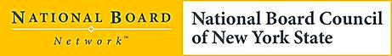

National Board Certification Awareness Session

NYSUT Headquarters
March 18, 2015

Presenter: Annette Romano

- How and why NBPTS began
- The parts of the NBC process
- How teachers are being supported
- Why teachers pursue NBC

